Лабораторна робота №5

Варіант 10  
8, 4, 2, 1 + 4

|  |  |  |  |  |  |  |  |  |  |  |  |  |  |  |  |  |
| --- | --- | --- | --- | --- | --- | --- | --- | --- | --- | --- | --- | --- | --- | --- | --- | --- |
|  | Двійковий код | | | | |  | Двійково-десятковий код | | | | |  | Корекція | | | |
|  | p′ | S3′ | S2′ | S1′ | S0′ | +4 | p | S3 | S2 | S1 | S0 |  | S3″ | S2″ | S1″ | S0″ |
| 0 | 0 | 0 | 0 | 0 | 0 | 0+4 | 0 | 0 | 1 | 0 | 0 | 0 | 0 | 1 | 0 | 0 |
| 1 | 0 | 0 | 0 | 0 | 1 | 1+4 | 0 | 0 | 1 | 0 | 1 | 1 | 0 | 1 | 0 | 0 |
| 2 | 0 | 0 | 0 | 1 | 0 | 2+4 | 0 | 0 | 1 | 1 | 0 | 2 | 0 | 1 | 0 | 0 |
| 3 | 0 | 0 | 0 | 1 | 1 | 3+4 | 0 | 0 | 1 | 1 | 1 | 3 | 0 | 1 | 0 | 0 |
| 4 | 0 | 0 | 1 | 0 | 0 | 4+4 | 0 | 1 | 0 | 0 | 0 | 4 | 0 | 1 | 0 | 0 |
| 5 | 0 | 0 | 1 | 0 | 1 | 5+4 | 0 | 1 | 0 | 0 | 1 | 5 | 0 | 1 | 0 | 0 |
| 6 | 0 | 0 | 1 | 1 | 0 | 6+4 | 1 | 0 | 0 | 0 | 0 | 6 | 1 | 0 | 1 | 0 |
| 7 | 0 | 0 | 1 | 1 | 1 | 7+4 | 1 | 0 | 0 | 0 | 1 | 7 | 1 | 0 | 1 | 0 |
| 8 | 0 | 1 | 0 | 0 | 0 | 8+4 | 1 | 0 | 0 | 1 | 0 | 8 | 1 | 0 | 1 | 0 |
| 9 | 0 | 1 | 0 | 0 | 1 | 9+4 | 1 | 0 | 0 | 1 | 1 | 9 | 1 | 0 | 1 | 0 |
| 10 | 0 | 1 | 0 | 1 | 0 | 10+4 | 1 | 0 | 1 | 0 | 0 | 10 | 1 | 0 | 1 | 0 |
| 11 | 0 | 1 | 0 | 1 | 1 | 11+4 | 1 | 0 | 1 | 0 | 1 | 11 | 1 | 0 | 1 | 0 |
| 12 | 0 | 1 | 1 | 0 | 0 | 12+4 | 1 | 0 | 1 | 1 | 0 | 12 | 1 | 0 | 1 | 0 |
| 13 | 0 | 1 | 1 | 0 | 1 | 13+4 | 1 | 0 | 1 | 1 | 1 | 13 | 1 | 0 | 1 | 0 |
| 14 | 0 | 1 | 1 | 1 | 0 | 14+4 | 1 | 1 | 0 | 0 | 0 | 14 | 1 | 0 | 1 | 0 |
| 15 | 0 | 1 | 1 | 1 | 1 | 15+4 | 1 | 1 | 0 | 0 | 1 | 15 | 1 | 0 | 1 | 0 |
| 16 | 1 | 0 | 0 | 0 | 0 | 16+4 | * | * | * | * | * | 16 | * | * | * | * |
| 17 | 1 | 0 | 0 | 0 | 1 | 17+4 | * | * | * | * | * | 17 | * | * | * | * |
| 18 | 1 | 0 | 0 | 1 | 0 | 18+4 | * | * | * | * | * | 18 | * | * | * | * |
| 19 | 1 | 0 | 0 | 1 | 1 | 19+4 | * | * | * | * | * | 19 | * | * | * | * |

S0″ = 0

S1″ = S3″ = p = S2S1 V S3

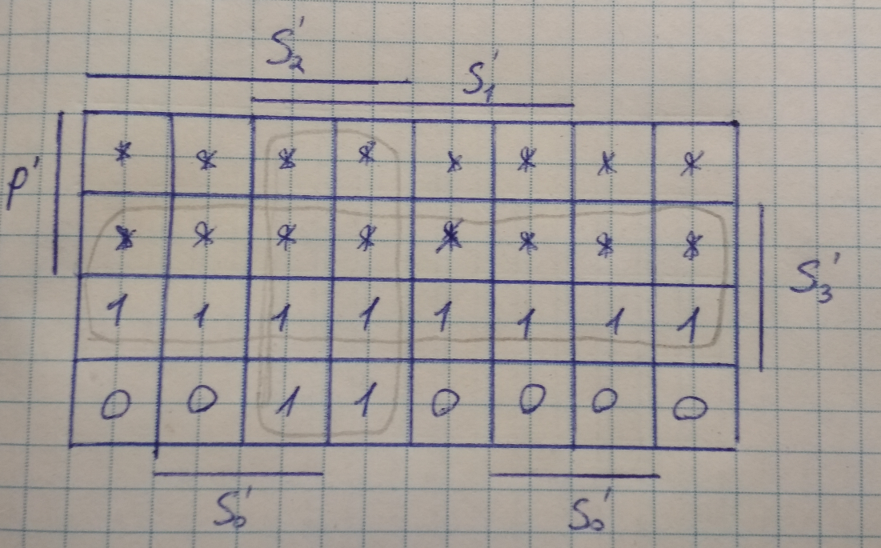

S2″ = 31 V 32

